TARA KENNEDY - TEXTILE ARTIST

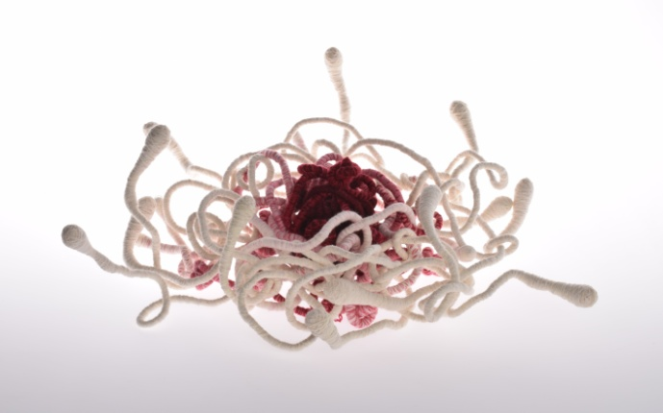
Tel: 07929 207923
Email: info@tarakennedy.co.uk
Web: www.Tarakennedy.co.uk
Instagram : @Tarakennedytextileart

SKILLS
I am a Textile artist working mostly with mixed yarns and fabrics using techniques including machine knitting, felting, wrapping, hand and machine stitching to create textile sculptures, wall hangings and canvas art. Alongside this I make detailed pencil drawings of my pieces.

EDUCATION
​2016 - 2018: University for the Creative Arts - Masters in Textile Art - Distinction
2009 - 2016: Open College of the Arts - BA Honours in Fine Art & Textiles
1985 - 1989: Berkshire College of Art and Design - OND & HND in Fashion Design

EXHIBITIONS & SITE SPECIFIC WORK
Dec 2020: Making Matters Pop up Gallery Shop, Farnham
​Dec 2019: Vlieseline Fine Art Textile Award: The Knitting Stitching Show, HCC, Harrogate
Nov 2019: Transition - group exhibition: The Oxmarket Gallery, Chichester
Nov 2019: Vlieseline Fine Art Textile Award: The Knitting Stitching Show, RDS, Dublin
Oct 2019: Vlieseline Fine Art Textile Award: The Knitting Stitching Show, Alexandra Palace, London
Aug 2019: Vlieseline Fine Art Textile Award: Festival of Quilts, Birmingham NEC
May 2019: The Latch String is Always Out: The Textile Centre, Blonduos, Iceland
Feb 2019 : Hope, Exhibit Here, Menier Gallery, London
Feb2019: Unravel Festival, Farnham Maltings, Farnham
Jan 2018: Transition Henley - group exhibition, The Old Fire Station Gallery, Henley on Thames
Oct - Dec 2018: Home/Hope - Workers Gallery, Ynyshir, Wales
Sept 2018: Transition - group exhibition, London Design Festival - Espacio Gallery, London
Sept 2018: Hope Emerging, MA Graduate show - James Hockey Gallery - UCA, Farnham
Nov 2017: Harmony installation - St. Marys Church, Purley-on-Thames, Berkshire
June - Aug 2017: Spine Trees - Heathland Artworks - Farnham Heathlands
June - Dec 2017: Stories in the Making - Craft Study Centre, Farnham
May - June 2016: Inspired By - Morley Gallery, London
Aug 2016: Reading Arts Week, Reading Town Hall exhibition

WORK EXPERIENCE
2019 - present: Chairman of Transition Craft and Design
2019: Member of Textile Echoes, a group of 4 textile artists
2018 - present: Member of Transition Craft and Design collective
1990 - 2010: Kennedy Design: my own craft and design business producing knitwear, hand and machine stitched pictures and jewellery. Exhibiting and selling at Craft and Design shows, trade shows, art galleries and gift shops.
​

BIBLIOGRAPHY
​May 2017 - Kennedy, Tara: Stitched and Bound Piece, Stories in the Making booklet

CURATED PROJECTS
​Oct 2019: Transition Craft and Design exhibition, Oxmarket, Chichester (co curated)
June - Dec 2017: 'Stories in the Making', Craft Study Centre, Farnham - curated exhibition of archive items along with artists response pieces

AWARDS
2018: People's Choice Award - Home/Hope Exhibition, Workers Gallery, Ynyshir, Wales

PRESS & OTHER

2021: Podcast interview with Materials Inside, Goodfellow Ltd
2020: Article: 'In the Studio' - the Woven Tale Press online magazine
2020: Article: Textile Centre Art Residency catalogue
2020: Article: the Woven Tale Press magazine
2019: Featured article: Feltmakers Ireland, The National Guild of Felt Makers
2019 - present: posts on Textile Echoes a-n Blogg,
​2019: Shortlisted for Hot House professional development programme

