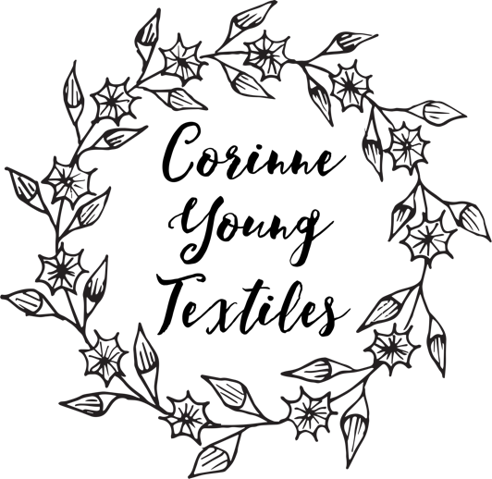
www.corinneyoungtextiles.co.uk

CAREER HISTORY
1997-2000 Interior Design Consultant/Interior Decorator (self-employed)
2003 - Present - Textile Artist, Designer and Maker
October 2007 – September 2013 - Gallery Manager at Gallery Forty-Nine, Old Town, Bridlington

EDUCATION

2000 – 2003 - BA (Hons) Degree in Textile Design

AWARDS AND EXHIBITIONS

September 2002 – Sponsorship award from Madeira Threads for final year work
June 2003 – Awarded Licentiateship from Society of Designer Craftsmen
June/July 2003 – Exhibited at New Designers, London
January 2004 – Article in Embroidery Magazine (from a meeting at Fashion & Embroidery Show in Harrogate)
February 2004 – Exhibition with the Society of Designer Craftsmen at the Mall Galleries, London
March 2004 – Award of Distinction Licentiateship from Society of Designer Craftsmen
July 2004 – Awarded Grant from Arts Council, England
October/November 2004 – Awarded stand at Knitting & Stitching, Show - Dublin, Harrogate and London
May 2005 – Exhibition at 99 Bishopsgate, London
August 2005 to March 2006 - Commissioned to make publicity pieces by Kevin Wallace Limited for the Premiere on stage of ‘ The Lord of the Rings’ in Toronto, Canada.
April 2007 – Commissioned to make more pieces for opening of Lord
of the Rings in London
June 2011 – Joint exhibition ‘A Safe Room’ at Burton Constable Hall with Gideon Johnson.
July 2013 – Article in Yorkshire Life Magazine
March 2014 – Exhibition and curation of ‘The Garden Room’ work at RHS Harlow Carr, Harrogate
June 2014 – Participated in North Yorkshire Open Studios
June 2014 – Article in Yorkshire Post Magazine
July 2014 – Animal Magic at the Masham Gallery
September 2014 – Feature on www.textileartist.org
December 2014 – 6 page article in Pretty Nostalgic Compendium
March 2015 – Craft Centre & Design Gallery, Leeds – Mixed Exhibition
March 2015 – Selected for Crafts Council Maker Directory
May 2015 – Silver Award in Craft & Design Selected Makers 2015
June 2015 – Grow Show, London – SGD Garden Installation with Nature Redesigned
August 2015 – Completion of commission for 20 framed artworks for ‘The Modern Pantry’ restaurant in Finsbury Square, London
March/April 2016 - Cover and major article in Creative with Workbox magazine
June 2016 - 6 page article in Homestyle Magazine
June 2016 – Four woman show at the Bath House, RHS Harlow Carr, Harrogate
August 2016 – ‘Botanical’ Exhibition at the Yorkshire Arboretum, Castle Howard
September 2016 – Took part in Staithes Arts Festival
October 2016 – Showcase with Serena Partridge at Chawton House Library, Hampshire
December 2016 – ‘Loves, Lives and Loss’ show with Traces London at National Trust Fenton House, Hampstead, London
June 2017 & 2019 – North Yorkshire Open Studios
August 2017 – Botanical Exhibition at Yorkshire Arboretum with Shirley Vauvelle
September 2017 – Kitchen Table Talent article in Country Living Magazine
December 2017 – Stand at Country Living Fair, Harrogate
January 2019 – ‘Ebb & Flow’ exhibition at Arteria Gallery, Lancaster
May 2019 – ‘Fibre’ – Textile Art Exhibition at Heart Gallery, Hebden Bridge
May 2019 – ‘Inspired by Nature’ feature in PRIMA Magazine
June 2019 – Silverdale & Arnside Art Trail
October 2019 – Art & York – Stand & ‘French Botanic’ Roomset with The French House
March 2020 – Feature in Emporium section in Country Living Magazine
May, August & November 2020 – Country Living POP up Artisan Fair (online)

Testimonial from William Bennett of Kevin Wallace Limited

“Thank you for your tremendous work on the commissioned pieces for The Lord of the Rings opening night event. They exceeded our expectations and generated much attention and praise from the guests. I can only marvel at the amount of skill and attention to detail that went into each panel. We have now installed the work in our offices and look forward to enjoying them for many years to come”.

Testimonial from Wendy Morris, Judge, Craft & Design Magazine Selected Maker Awards 2015

“Minute study of the botanical detail of her subjects may be the starting point for Corinne’s work, but she shows us that she can take her observations in a range of directions depending on the qualities she seeks to highlight and the context or purpose of the piece she is making. By exercising tight control over the fundamental materials and techniques she uses, even hand making her own linen paper as a base, she gives herself the freedom to incorporate vintage fabrics and serendipitous finds while still retaining the integrity of her designs.”

