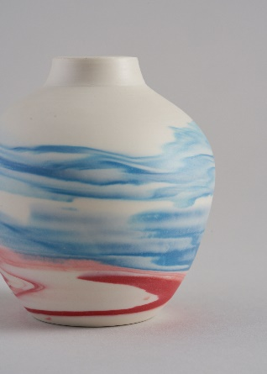
Lindy Barletta Ceramics

Figure 1: London Sunset

A potter for 25 years, Lindy has been quietly making and selling her work at designer maker and ceramic fairs, select galleries and open studios, whilst teaching the joys of clay to adult students at her workshop.

After studying Textiles at Hereford College of Art (1977-79) and a career in management at the Chelsea Arts Club (1981-87) and a second career in the Interior Design of grand houses around the world (1988-94), Lindy found ceramics and took every course available whilst working and bringing up a family. She has taken master classes with the best contemporary makers today, including a residential course at the Brookhouse Pottery, with David & Margaret Frith, classes with Takashi Yasuda, Phil Rogers, Gareth Malone, Carina Ciscato and Chris Keenan. After a C&G course in Ceramics L3 and a Glaze and Firing programme, Lindy opened her first studio 25 years ago.

Downsizing when Covid struck, the studio is now in the garage at home in SW London, Lindy works full time as a potter. Her signature style is making landscapes in coloured porcelain clays. Experimenting with colouring clay and developing the collection continuously, this technique has taken 10 years to perfect.

Lindy is well travelled and the inspiration for these landscapes comes from dry river beds, mountains, lakes, deserts, coastlines and seascapes in Argentina, New Zealand and South Africa. Lindy makes her porcelain clay in different colours adding stains and oxides, layers these and throws on the wheel to emulate the Earths strata, layers and colours in the landscape. The work is functional with a clear glazed interior and the outside is polished marble smooth and tactile. This process is time consuming, making the clays from the start and finishing the work by burnishing, sanding and polishing throughout the stages. A little more of the picture in clay is revealed at each stage of the making process.

Lindy is Chai at London Potters. Having joined as an adult student, LP encouraged & supported Lindy in her ceramic journey. Lindy aims to modernise this small charity, appealing to a more diverse audience and attracting younger members and expanding the educational remit with a series of workshops and demonstrations for members. Kate Malone MBE has just accepted to be Honorary Ambassador for London Potters, we will be working together on aims and causes in common, whilst Kate supports the work we do.

Lindy is also a selected member of the Society of Designer Crafts and a member of the Crafts Council.

Up coming Exhbitions:
Craft Festival, Bovey Tracey. June 2022
Celebrating Ceramics, Waterperry. July 2022
Art in Clay, Windsor, August 2022
Art in Clay, Farnham, November 2022

Recent Exhibitions:
Art in Clay Farnham 2019 & Windsor 2021
Celebrating Ceramics 2019 and 2021
Chelsea Arts Club 2019 In the Cabinet Exhibition.
Handmade Chelsea & Kew 2016-2019
Art in Craft Belgravia 2021
Contemporary Craft 2018

Publication Features
LP Mazagine Meet the Maker
Chelsea Arts Club Yearbook 2022

Stockists
New Ashgate Gallery, Farnham
Iona House Gallery, Woodstock
Bell Fine Art, Winchester

Commissions:
Art Consultants, Artelier Ltd
Winch Design, London
Kinkatou Ltd London

Memberships:
Licentiate member of the Society of Designer Craftsmen
Crafts Council member

Ceramic Qualifications:
Open College Accrediation
City & Guilds Design for Ceramics Level 3 2002
London Open College Network:
Ceramic studies, Glaze and Firing Technology. 2003 Levels 2 and 3
National Open College Network:
Ceramics, Throwing and Turning - Level Three 2005

Website: https://www.lindybarlettaceramics.co.uk
Instagram: @lindybarlettaceramics

Studio: The Garage Studio, 42 Clarelawn Avenue, London SW148BG
Email: lindy.barletta@btinternet.com
Tel: 07887483275

