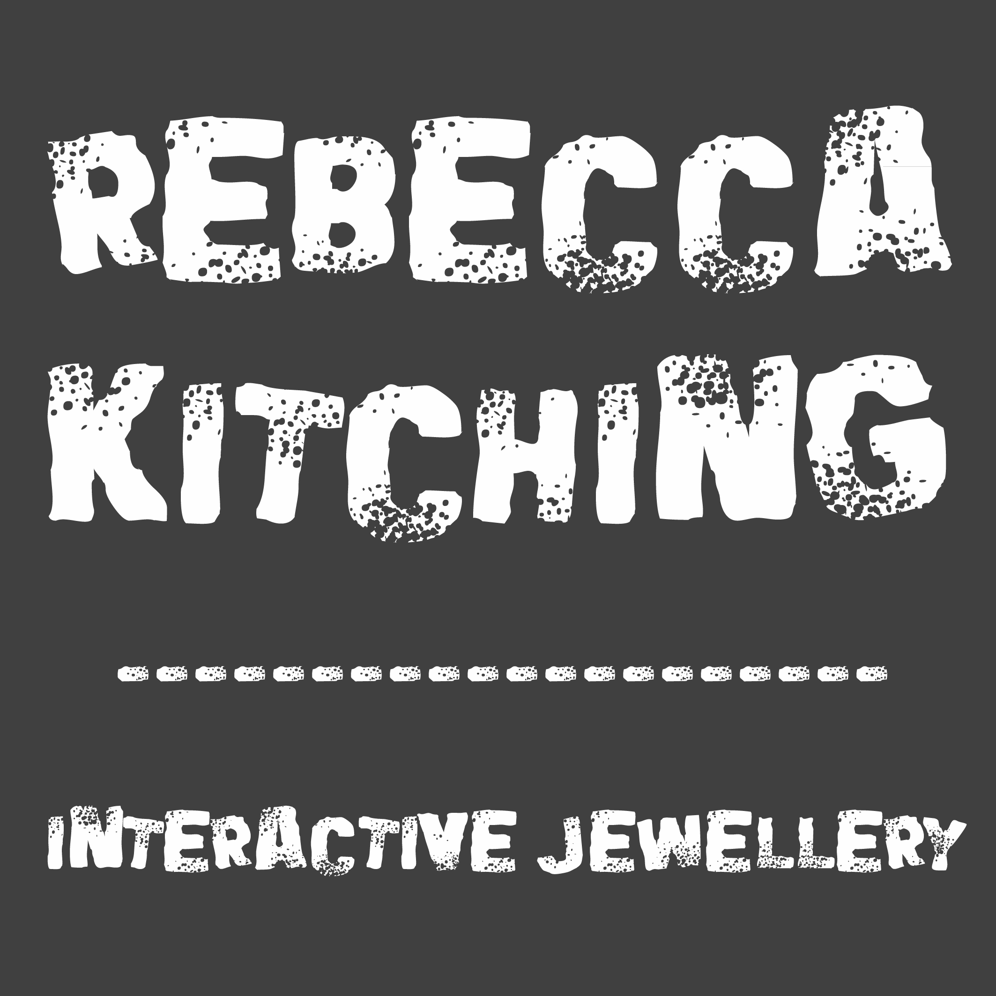
Rebecca Kitching Interactive Jewellery
CV.

Education.
(most recent first)

University – Sheffield Hallam 2004 – 2007
BA (Hons) metalwork and jewellery (second class)

Collage – York collage 2000 - 2002 ND 3D Design crafts (merit)
York collage 2002 - 2004 HND 3D Design crafts (distinction)

Courses

Prince’s trust Explore Enterprise Course Jan 2013 14th-17th.
Skills to run a business
Marketing and selling
Pricing, bookkeeping and cash flow forecasting
Business plan topics and structure
Mentoring

Craft fairs/ shows
(most recent first)

- Great northern contemporary craft fair, July 2020 (online show)
- Etsy made local, Sheffield, Aug 2020 (online show)
- Harley gallery Christmas fair, Worksop, Nov 2019
- Made by hand – craft fair, Cardiff, Nov 2018
- Saltaire makers fair - part of the arts trail, Saltaire, May 2018
- Made by hand – craft fair, Cardiff, Nov 2017
- Art& - contemporary art and craft fair, York, Oct 2017
- Art market - craft fair, Holmfirth, Nov 2015
- Great northern contemporary craft fair, Manchester, 0ct 2015
- Little northern contemporary craft fair, Manchester, April 2014
- Great northern contemporary craft fair, Manchester, Oct 2014
- Millennium gallery's craft market, Sheffield, Oct 2014

