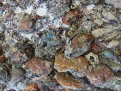
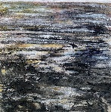
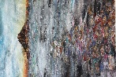
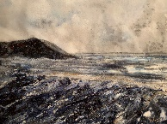
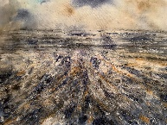
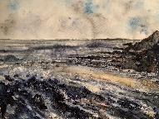
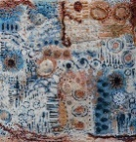
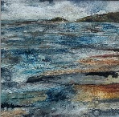
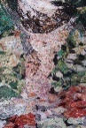

Curriculum Vitae

Personal Details

NAME: Wendy Alicia Greaves
ADDRESS: Berry Mill House, Mill Lane, Berrynarbor, North Devon, EX34 9SH
HOME TEL: 07900493910 EMAIL: wagreaves17@gmail.com
NATIONALITY: British WEBSITE: www.wendygreaves.com
DRIVING LICENCE: Full / Clean INSTAGRAM: @wendy.greaves.textiles
FACEBOOK: https://www.facebook.com/profile.php?id=100089726310608

Employment
Teacher of Fine Art Textiles, Costume, Fashion & Painting - Oakham School 1991 -2022

Education
Leicester De Montfort University (BA hons Constructed Textiles): Sept 1987- May 1990
Leicester De Montfort University (PGCE) Education: Sept 1990 - June 1991

Memberships
Member of The Society of Designer Craftsmen
Associate member at Appledore Crafts Company
Member of Embroiderer’s Guild
Member of CrOW (creative older women)
Member of North Devon Arts
Member of Artmakers
Member of Devon Artist Network

Publications
Feature in Textile Fibre Forum Magazine June 2025
Unravelled Journeys – Wendy Greaves 2025
101 Contemporary Artists 2023 Collect Artwork
Landscape 2023 Magazine – Collect Artwork

Exhibitions & Highlights
2025 The National Embroidery Awards (NEC)
Burton in Bideford Craft Gallery Interview for Flourish-hub (online subscription site)
Appledore Crafts Company Gallery
Rosemoor RHS – The Wool & Fibre Weekend
Ilfracombe Art trail (open studio)
Delivering various workshops – group and individual at both my studio and other venues
Participation in the Embroiderers Guild Members project and challenge
Arlington Court NT
Natural Fibre & Heritage Craft festival – Coldharbour Mill
RLNI exhibition
Member of Artmakers – regular exhibitions
Mr X Stitch competition
Embroiderers Guild Members Challenge
Appledore book festival
2024 Ilfracombe Art Trail Open Studio Delivery of several 1-1 and group workshops (2024- present) Natural Fibre & Heritage Craft festival – Coldharbour Mill (3 weeks) RNLI exhibition – Instow Artmakers Upstairs exhibition Appledore Book festival Appledore Gallery Exhibition (1 Month) Arlington Court (Artmakers) Exhibition Burton in Bideford Open exhibition Created - Contemporary & Heritage Crafts Festival
(
2023 Featured in an online exhibition via Curator Space.
Member of the Textile Art Organisation Stitch Club
Open studio (Ilfracombe Art Trail)
Member of Devon Artist Network (2023 – present)
Member of Artmakers (2023 – present)
Burton in Bideford Open exhibition
RLNI exhibition-Instow
Ilfracombe Art Trail
Devon Art Trail

2022 Celebration of my own explorations whilst teaching. “Unravelled Journeys” (Oakham School)
Large commission of Sennen Harbour
Short listed for the Royal Academy of Marine Artists exhibition
Burton at Bideford Open Exhibition
Moved to North Devon to focus on my own artwork

Statement
My love of textiles is rooted in a desire to capture the tactile, mesmerising qualities found in nature and organic form. I believe the ebb and flow of natural structures, those quiet, intricate patterns etched into the landscape, hold endless possibilities for expression through cloth and stitch.
While landscapes have long inspired artists, I find that fibre and textile art offer a uniquely embodied way to engage with place. My work invites viewers to "watch where you tread", to slow down, notice, and form a deeper, more intimate connection with the natural world.
Rooted in the dramatic and fragile landscapes of North Devon, my practice does not aim to replicate what I see. Instead, it seeks to explore the textures, moods, and quiet rhythms of place—interpreted through the language of textiles. It is an ongoing inquiry, a mapping of presence, a poetic conversation with land and memory.
My process is intuitive and material led. I choose fabrics for their honesty, texture, and ability to carry history. Stitching with immediacy and sensitivity, I build layered, abstract surfaces through mono printing, appliqué, and embroidery. Recent explorations include working with locally sourced wool and solar dyeing, infusing the cloth with gentle, natural hues and a sense of place, while consciously moving away from synthetic colour.
The surface of the fabric becomes transformed by the techniques that I employ, just as the surface of the landscape transforms under changing light and tide. I do not seek to imitate, but to investigate, to translate atmosphere into texture, and emotion into fibre.
My practice is experimental and multi-layered: combining felting, embellishment, mark-making and stitch. Each piece evolves organically through touch and discovery. At its core is a profound sense of fragility, of material, of landscape, of our environment. This latest collection honours the North Devon coastline: its overhanging caverns, tangled seaweeds, murky rock pools, and the sea’s fierce, dramatic offerings cast ashore by the Atlantic.

