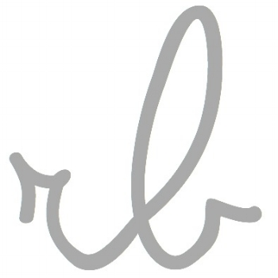

…C:V

1971 born margate, kent

pre art foundation / textile- art a levels 1988 – 1989
fashion & textiles – Rochester art college 1989 – 1991
Practicing Artist 2002 – present
Author & Freelance writer 2008 – present
MA Ceramics 2018 – present

exhibitions

rural crafts association selling various venues – 2003
‘wrapped’ – paperweight, farfield mill – 2004
Kendal brewery arts – contemporary craft market – 2004
Stockport art gallery – designer crafts showcase – 2004
‘past influence’ jelly leg’d chicken – 2005
works in paper, platform gallery – 2005
bovey tracey contemporary crafts fair – 2005
skipton contemporary craft showcase – 2005
Christmas showcase platform gallery – 2005
Featured artist – gallery 23, arteria – 2005
Leeds art & design centre – 2006
Ripple four art fair – 2006
Platform gallery – north of Watford exhibition – 2006
Weave paper print, neo gallery – 2006
North Yorkshire Open studios - 2007
Published author, interiors and craft books – 2008 to present
rb ceramics – selling online – 2015 to present
North Yorkshire Open Studios - 2017

solo exhibitions

lay•er, neo gallery cockermouth feb – 2006

awards & residencies

arts council professional development grant feb 2005
Brigit Skiold Curwen print bursary/residency – 2005

publications & reviews

Style Magazine – 2004
Craft galleries guide 2005-2006
Book - Granny chic, Kyle Books – 2012
Book - Pamper Your Pooch, Kyle Books – 2014
Book - Forgotten Ways for Modern Days, Kyle Books - 2015
Mollie Makes – Featured home & studio 2012
You Magazine – Mail on Sunday – 5 piece spread 2012, 2015
The Simple Things – 2012, 2014, 2015
Country Living – 5 piece spread 2015
Various Other Magazines and articles

Books Published in following countries

Japan
Germany
Holland
Portugal
USA
Australia
Italy
Spain

Website – www.rachelleblondel.uk
Instagram rbceramics | rachelleblondel

